SAVEETHA SCHOOL OF ENGINEERING
SAVEETHA INSTITUTE OF MEDICAL AND TECHNICAL SCIENCES
CHENNAI – 602105
DEPARTMENT OF COMPUTER SCIENCE AND ENGINEERING
Engineer to Excel
CSA05-DATABASE MANAGEMENT SYSTEMS

EXP: 2
Date : 10-07-2026
DDL Commands with Constraints – PRIMARY, FOREIGN KEY, UNIQUE, CHECK

AIM: To add the constraints like primary key, foreign key, unique key and check using DDL commands.
Description:
PROCEDURE:
Step 1: Create the Movies table with the required attributes.
Step 2: Add PRIMARY KEY constraint on the M_id column.
Step 3: Add a UNIQUE constraint on the Ott column.
Step 4: Verify the table structure and insert movie records.
Step 5: Attempt to update the OTT value of movie M_id = 103 to Netflix.
Step 6: Observe that MySQL displays a duplicate entry error because the UNIQUE constraint prevents duplicate values.
Step 7: Drop the UNIQUE index created on the Ott column.
Step 8: Modify the Ott column to ensure it remains NOT NULL.
Step 9: Update the OTT value of M_id = 103 to Netflix again.
Step 10: Display all records to verify that duplicate OTT values are now allowed after removing the UNIQUE constraint.
Query 1:
ALTER TABLE movies ADD PRIMARY KEY (M_id);
OUTPUT 1 :
PRIMARY KEY:

SQL Query:
SHOW DATABASES;
USE collage;
SHOW TABLES;
ALTER TABLE JuiceShop
ADD PRIMARY KEY (Token_No);
DESC JuiceShop;

SELECT * FROM JuiceShop;
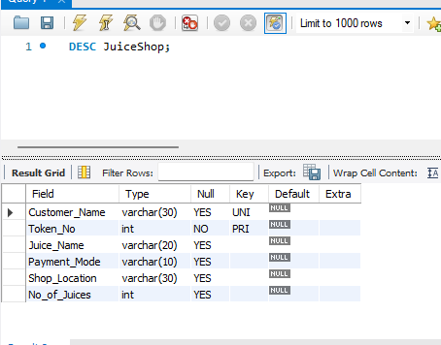

Output 2 :
SQL Query:

SHOW DATABASES;
USE collage;
SHOW TABLES;
ALTER TABLE JuiceShop
ADD CONSTRAINT UK_CustomerName
UNIQUE (Customer_Name);
DESC JuiceShop;
SELECT * FROM JuiceShop;
UNIQUE KEY

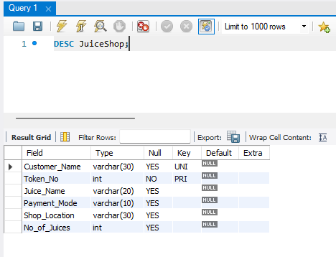

Output 3 :
SQL Query:
SHOW DATABASES;
USE collage;
SHOW TABLES;
ALTER TABLE JuiceShop
ADD CONSTRAINT CHK_Payment
CHECK (Payment_Mode IN ('UPI','Cash'));
SHOW CREATE TABLE JuiceShop;
SELECT * FROM JuiceShop;
INSERT INTO JuiceShop
VALUES ('Kumar',333,'Orange','Card','Main Road',2);
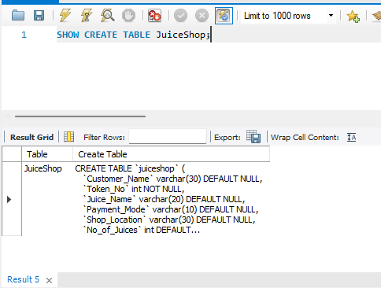

Output 4 :
SQL Query:

SHOW DATABASES;
USE collage;
SHOW TABLES;
CREATE TABLE Orders (
Order_ID INT PRIMARY KEY,
Token_No INT,
Order_Date DATE
);
ALTER TABLE Orders
ADD CONSTRAINT FK_Token
FOREIGN KEY (Token_No)
REFERENCES JuiceShop(Token_No);
SHOW CREATE TABLE Orders;
SELECT * FROM Orders;
INSERT INTO Orders
VALUES (1,321,'2026-07-31');
INSERT INTO Orders
VALUES (2,999,'2026-07-31');

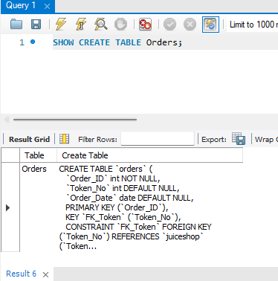

RESULT:

Thus, the PRIMARY KEY, FOREIGN KEY, UNIQUE KEY, and CHECK constraints were successfully created using DDL commands.
The constraints were verified successfully by executing SQL queries and validating the expected outputs.

